Project 1 Findings

By: Eric Meyer, Kristen Scaletta and Michelle Simek

**Overall Findings**

**Findings by Question**

**Question 1: Is there a relationship between “musicalities” and rank?**

*Process*: For this analysis, song rank was compared to various musicalities for the top 10 (artists or songs). Musicalities includes energy, danceability, tempo, loudness, etc.

*Related Plots and Findings*:

1. 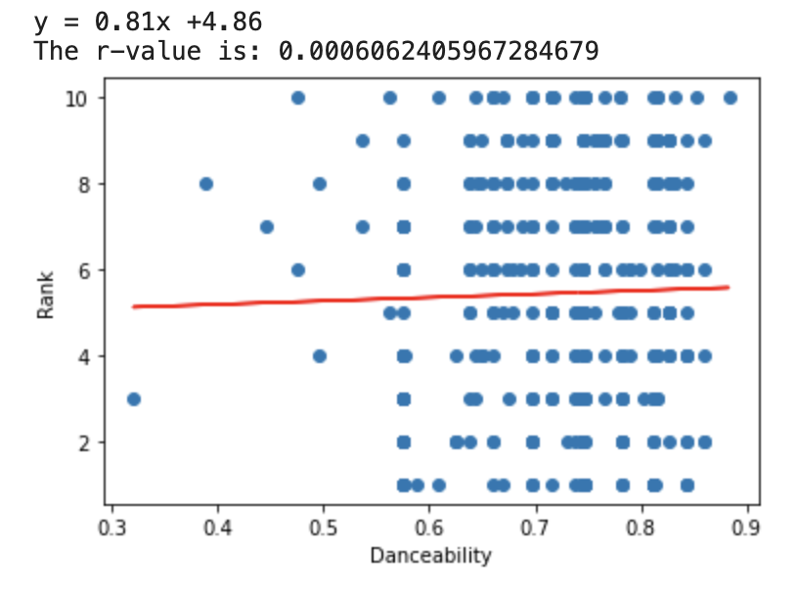

It appears there may be a very weak positive correlation between danceability and rank suggesting lower ranked songs (farther away from 1) may have more danceability.

1. 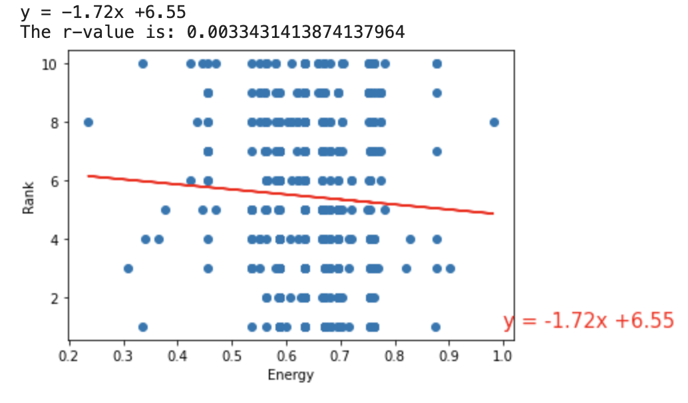

Findings: There appears to be a weak negative correlation between energy and popularity, suggesting higher ranked songs (being closer to 1) may have more energy.

*Overall Analysis*: ADD

**Question 2: Is there a relationship between “musicalities” and popularity?**

*Process*: Compared popularity to various musicalities for the top 10. Musicalities includes energy, tempo, loudness, etc.

*Related Plots and Findings*:

1. 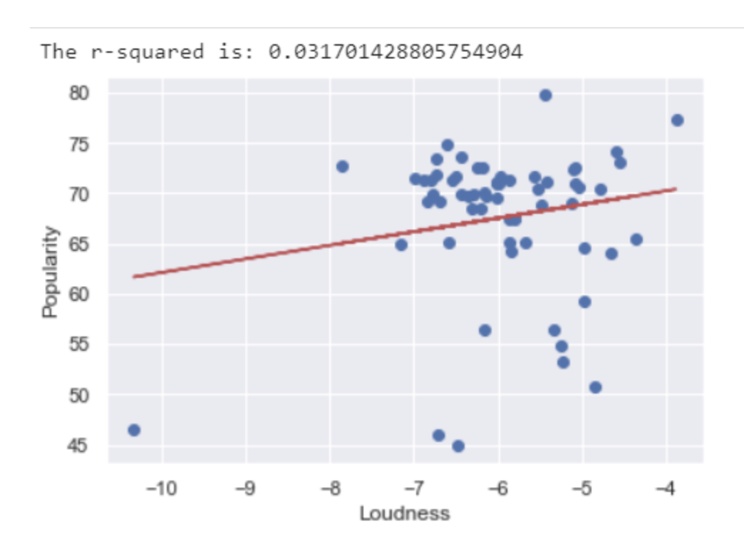

Findings: It appears there may be a positive correlation between loudness and popularity.

1. 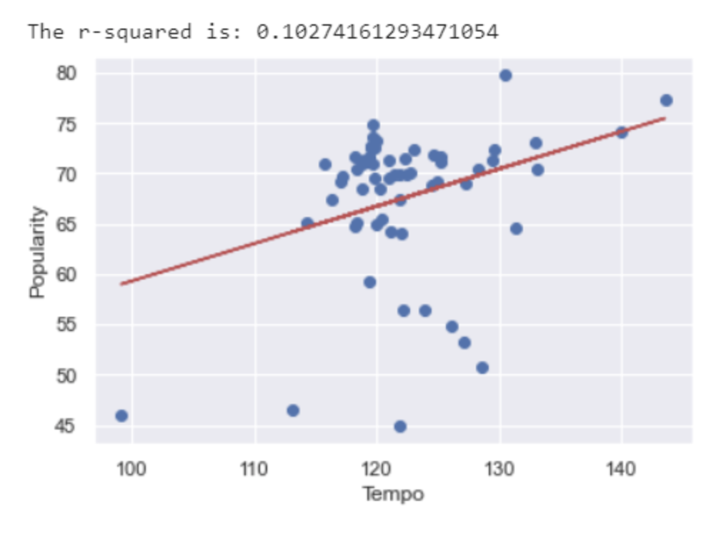

Findings: There appears to be a positive correlation between tempo and popularity. Looking further into the cluster would be interesting.

1. 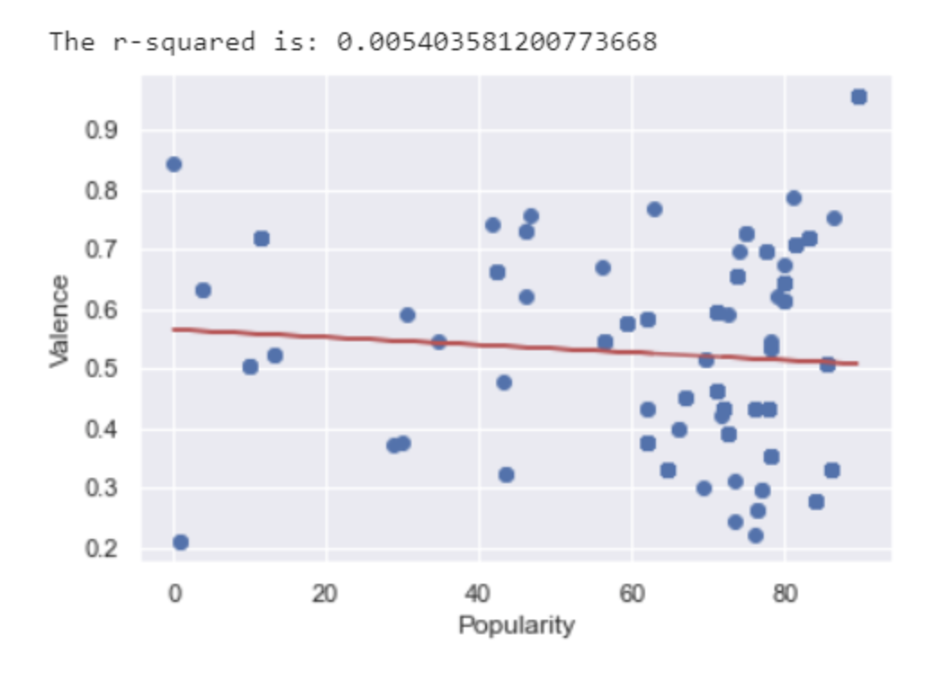

Findings: There appears to be a weak negative correlation between valence and popularity.

*Overall Analysis*: ADD

**Question 3: How does top artists’ rank across continents compare to their global rank?**

*Process*: Looked at individual top artists’ ranks in each continent in which they are ranked compared to how they are ranked globally.

*Related Plots and Findings*:

1. 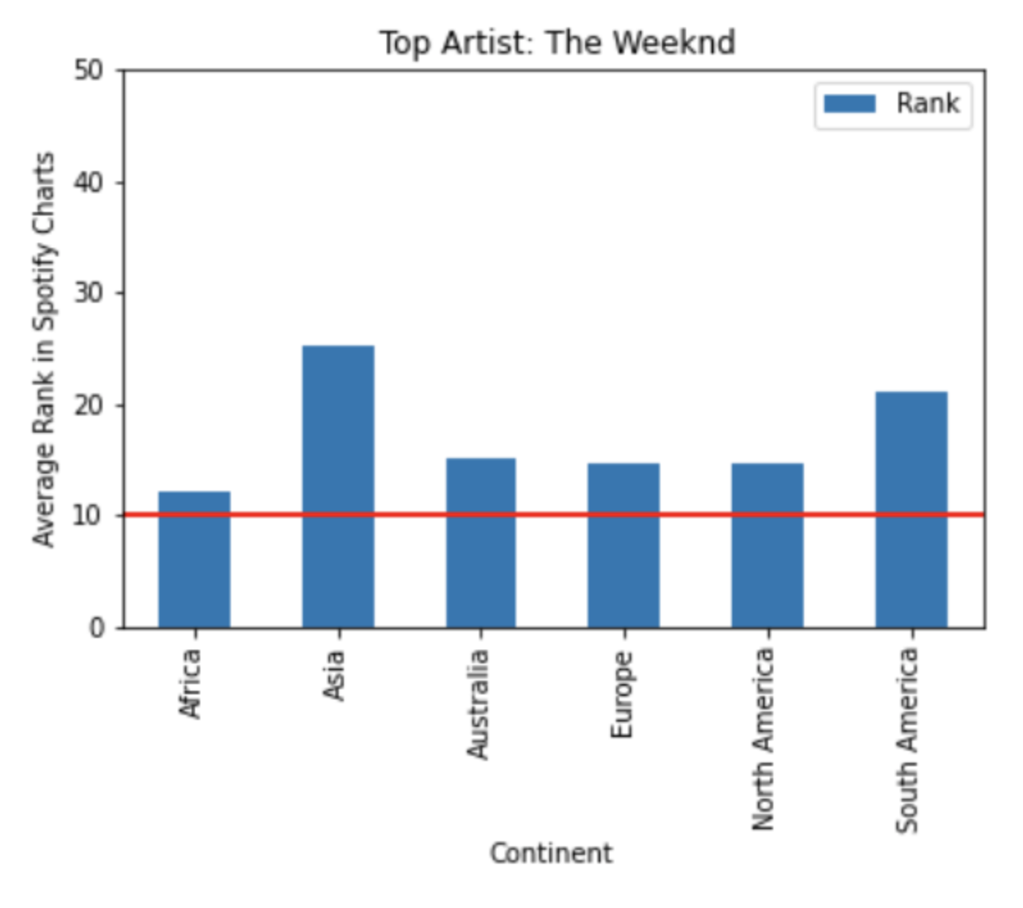

Findings: In this case, it appears the Weeknd is ranked higher globally (10) than in any continent. Would be worth looking into global ranking methodology

*Overall Analysis*: ADD

Instructions for our reference—to delete when done:

Create a write-up summarizing your major findings. This should include a heading for each "question" you asked of your data, and under each heading, a short description of what you found and any relevant plots.